**Drone Project Full Use Case Diagram**

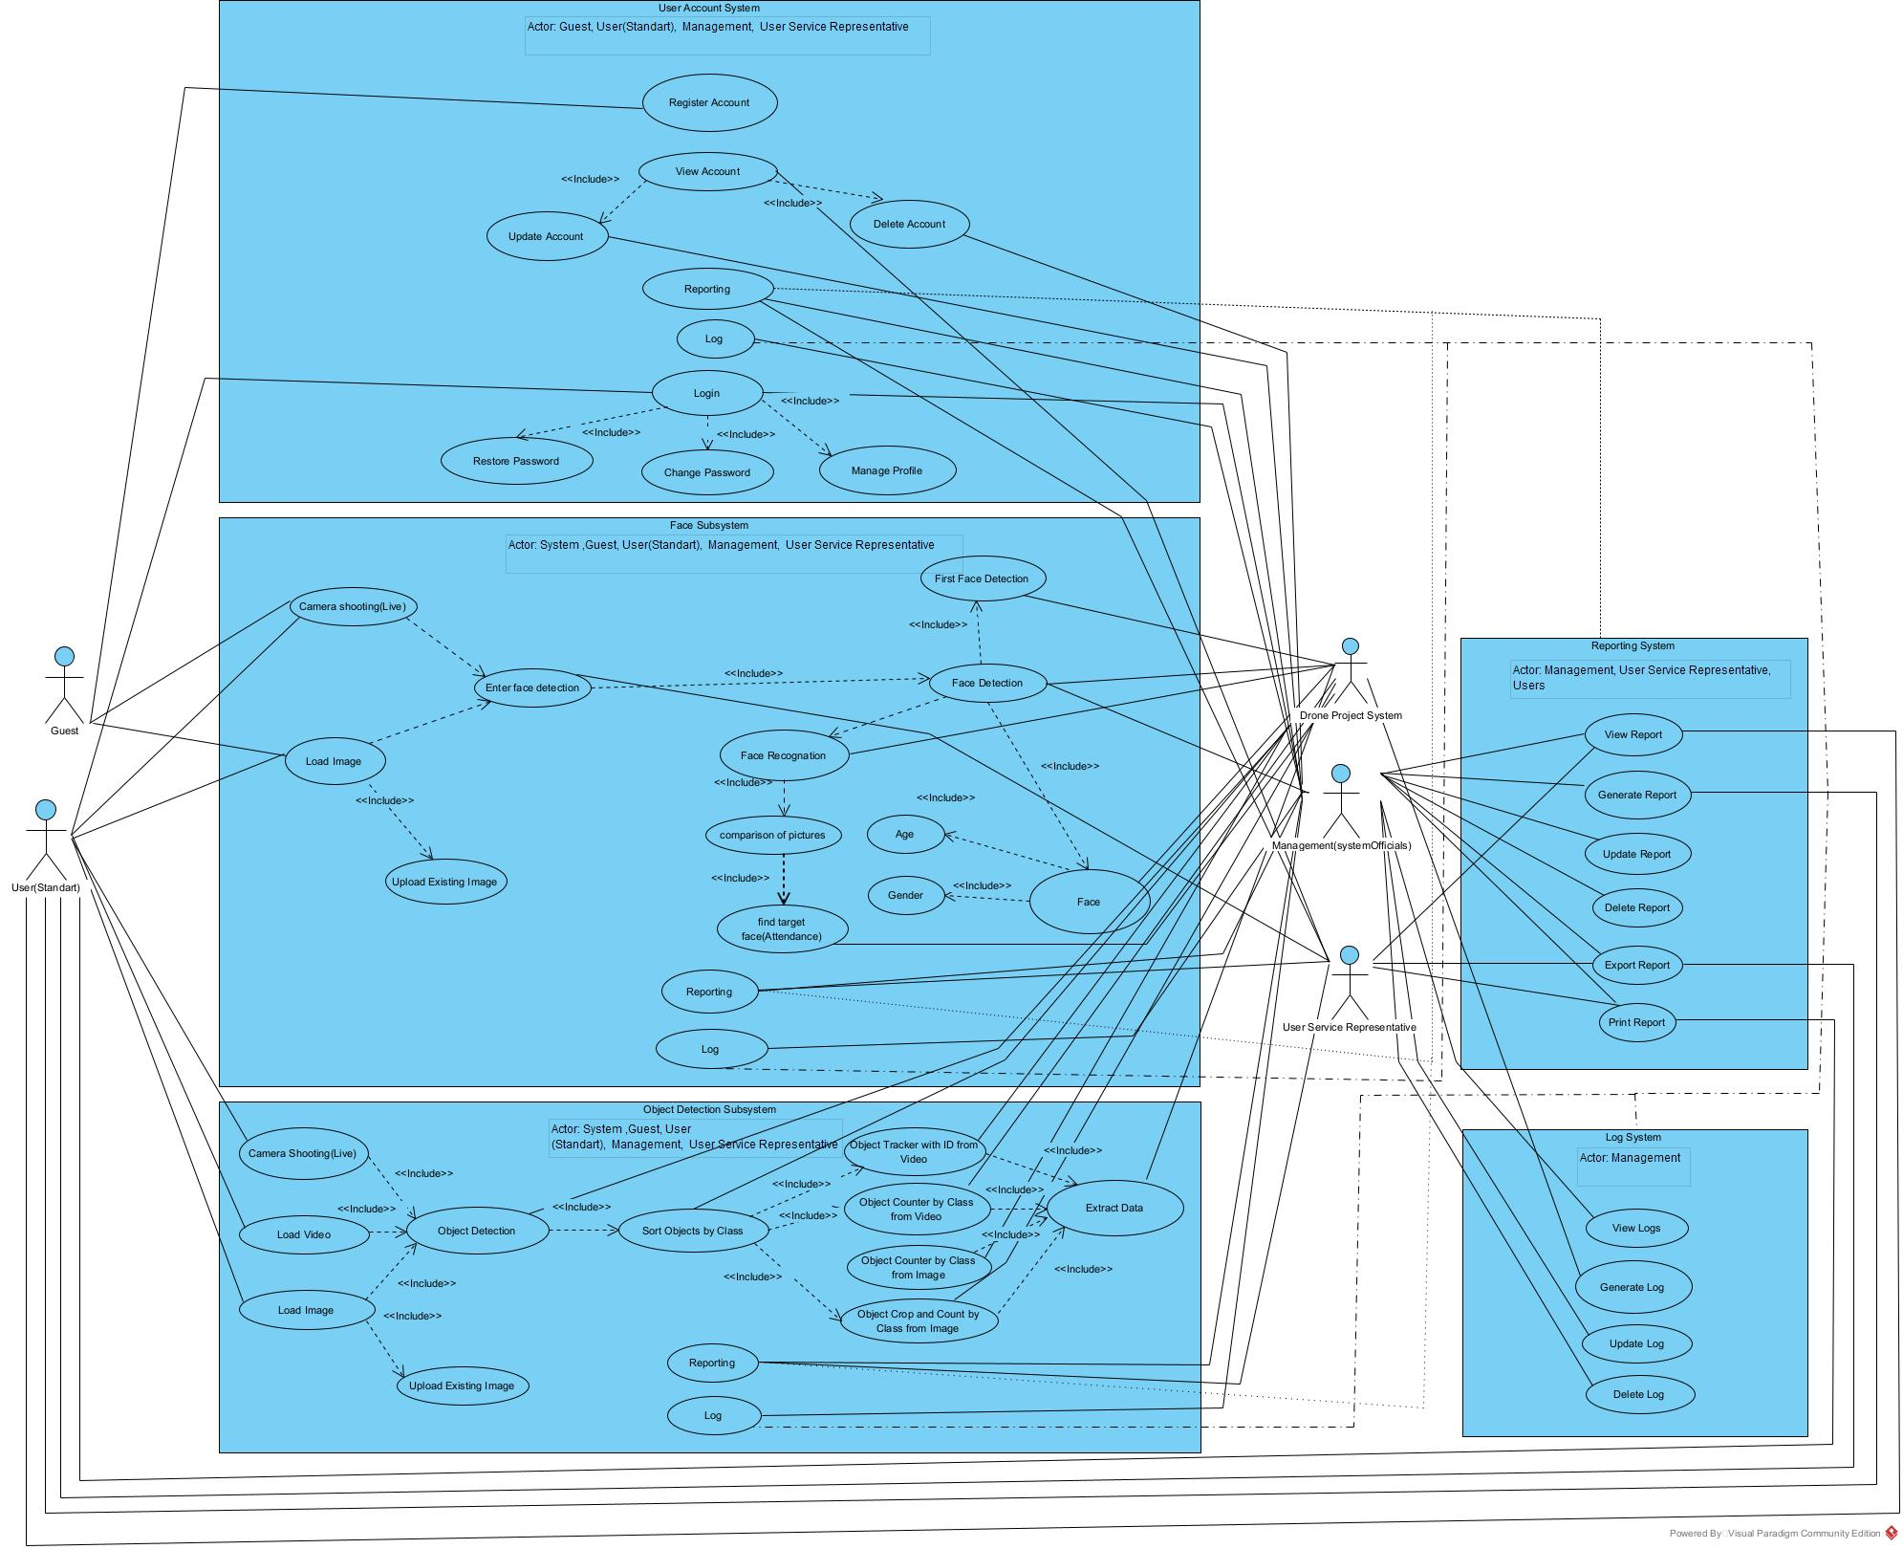

|  |  |
| --- | --- |
| **Actors** | |
| **Actor** | **Description** |
| Guest | People who are likely to be included in the Drone Project. |
| User(Standart) | They are authorized persons who can use the features of the Drone Project. |
| User Service Representive | They are people who help users using the Drone Project to support their use. |
| Management | They are both the owners and the people responsible for the management and execution of the Drone Project. |
| System(App) | It is the only software of Project Drone integrated across platforms. |
|  |  |

|  |  |
| --- | --- |
| **User Account Subsystem** | |
| **Use Case** | **Description** |
| Register Account | Create a user(standard) registration for the use of the Drone Project. |
| View Account | View / management of the created user(standard) account and use the usage features based on this situation. |
| Update Account | Updating the created user(standard) account. |
| Delete Account | Deleting the created user(standard) account. |
| Reporting | It is the status of all reporting studies of system users (standard) and system administration, about the user account subsystem. |
| Login | Created user(standard) can Login to the System and use the usage features based on this situation. |
| Restore Password | Renewing the password of the created user's(standard) account |
| Change Password | Changing the password of the created user's (standard) account |
| Manage Profile | Managing the profile information of the created user's(standard) account (name, surname, phone number, mail ..) |

|  |  |
| --- | --- |
| **Face Subsystem** | |
| **Use Case** | **Description** |
| Camera Shooting(Live) | Live video recording for the face subsystem of the drone camera |
| Load Image | Official uploads of the Drone Project's users (participation poll etc.) and visitors (when signing up) with their own faces |
| Upload Existing Image | Uploading already existing pictures of the Drone Project's users (participation polls, etc.) and visitors (when signing up) with their own faces |
| Enter Face Detection | In the Drone Project, the data taken by the system to determine the face of the face picture/live recording taken from the user or the visitor |
| Face Detection | Approval and acceptance of the data received by the system to determine the face of the face picture/live recording received from the user or the visitor in the Drone Project |
| First Face Detection | In the Drone Project, the first detected face in the webcam opened to record the faces of the users who want to register in the system, right after they enter the necessary information into the system. |
| Face | It is the use case that depends on the use cases of the operations to be performed on all the faces determined in the drone project. |
| Age | Finding age by looking at the designated face in the drone project |
| Gender | Finding gender by looking at the face identified in the drone project |
| Face Recognition | The first detected face in the webcam, which is opened to record the faces of the users who want to register in the Drone Project, immediately after entering the necessary information into the system.  (The person trying to register in the system, that is, the face of the visitor) |
| Comparison of Pictures | Users registered to the system in the Drone Project compare their own faces (live/picture) with the pictures of previously registered faces in the system while using the attendance submodule. |
| Find Target Face | It is the usage situation of the users registered in the system in the Drone Project, when using the attendance submodule, comparing the image of their own face (live/picture) with the pictures containing the previously registered faces in the system, and the corresponding search for a match submodule. |
| Reporting | In the drone project, the data of the face subsystem and the main module and submodules to which it is connected are made into report files/sections by making necessary inquiries. |
| Log | It is the use case of the system created in order to use informative data for the purpose of informing the management side of the functions performed in the program while the program is running, of the face subsystem and the main module and submodules to which it is connected in the drone project. |

|  |  |
| --- | --- |
| **Object Detection Subsystem** | |
| **Use Case** | **Description** |
| Camera Shooting(Live) | It is the live video (live) recordings made with the drone camera to find the objects of the users registered in the system in the drone project. |
| Load Vide | Users registered to the system in the drone project upload the previously taken video recording to the system to find the objects. |
| Load Image | Users registered to the system in the drone project upload the previously taken picture to the system to find the object |
| Upload Existing Image |  |
| Object Detection | Identification of objects in live recording, video or images uploaded to the system in the drone project |
| Sort Objects by Class | Grouping the recognized objects in the live recording, video or pictures uploaded to the system in the drone project according to their classes (Ex: 3 person, 3 bicycle, 1 dog) |
| Object Tracker with ID from Video | Grouping the recognized objects in the live recording or video uploaded to the system in the drone project according to their classes and specifying them by assigning a unique ID number. |
| Object Counter by Class from Video | Specifying the total number of recognized objects in the live recording or video uploaded to the system in the drone project by grouping them according to their classes |
| Object Counter by Class from Image | Specifying the total number of recognized objects in the picture uploaded to the system in the drone project by grouping them according to their classes |
| Object Crop and Count by Class from Image | In the drone project, the recognized objects in the picture uploaded to the system are grouped according to their classes, and all objects are cropped one by one, named according to their groups and unique ID (sequence number) numbers, and stored under the folder opened for the picture they belong to. |
| Extract Data | In the drone project, it is the use case of the data outputs that are created according to the main module and sub-modules (there is no sub-module under these main modules, but can be added in the future) in which the live video recording (live), previously shot video recording and pictures are used. |
| Reporting | In the drone project, the data of the object detection subsystem and the main module and submodules to which it is connected are made into report files/sections by making necessary inquiries. |
| Log | In the drone project, it is the use case of the system created for the purpose of using informative data for the object detection subsystem and the main module and submodules to which it is connected, with the aim of informing the management side of the functions performed in the program while the program is running. |

|  |  |
| --- | --- |
| **Reporting System** | |
| **Use Case** | **Description** |
| View Report | Ensuring that all subsystems of the drone project system (main system) and the main modules connected to them and the data groups created by the sub-modules connected to them when they are run are regularly displayed (listed) of the query results created in connection with dms (database management system). |
| Generate Report | Ensuring that all sub-systems of the drone project system (main system) and the main modules connected to them and the data groups created by the sub-modules connected to them when they are run, are regularly created based on dms (database management system). |
| Update Report | Ensuring that all subsystems of the drone project system (main system) and the main modules connected to them and the data groups created by the sub-modules connected to them are regularly updated according to the dms (database management system) query results. |
| Delete Report | Ensuring that all subsystems of the drone project system (main system) and the main modules connected to them and the data groups created by the sub-modules connected to them are regularly deleted based on dms (database management system). |
| Export Report | All subsystems of the drone project system (main system) and the main modules connected to them and the data groups created by the sub-modules connected to them when they are run are regularly exported (pdf, excel, csv) of the query results created in connection with dms (database management system). ,sql) provisioning. |
| Print Report | All subsystems of the drone project system (main system) and the main modules connected to them and the data groups created by the sub-modules connected to them when they are run, the regular export of the query results created in connection with the dms (database management system) directly via the printer (pdf ,excel,csv,sql) provision. |

|  |  |
| --- | --- |
| **Log System** | |
| **Use Case** | **Description** |
| View Log | Preparing and displaying (listing) informative data about all subsystems of the drone project system (main system) and the main modules connected to them and the parts of the system created by the sub-modules connected to them, exclusively for the system management (system owners) |
| Generate Log | Preparing informative data about all sub-systems of the drone project system (main system) and the main modules connected to them and the parts of the system created by the sub-modules connected to them when they are run, exclusively for the system management (system owners) by the system |
| Update Log | Updating the informational data about all subsystems of the drone project system (main system) and the main modules connected to them and the parts of the system created by the sub-modules connected to them when they are run, only regular data prepared by the system specifically for the system management (system owners) |
| Delete Log | Deletion of informative data about all subsystems of the drone project system (main system) and the main modules connected to them and the parts of the system created by the sub-modules connected to them when they are run, regular data prepared by the system only for the system management (system owners) |